**SET Assignment 2**

Member1: Rutikesh Balkrishna Sawant 2019BTECS00034

Member2: Nikhil Rajendra Danapgol 2019BTECS00036

Batch: T1

Date: 13/02/2022

Q1: Information about IDE/Software/Framework: **Anaconda**

1. Original author:

Peter Wang and Travis Oliphant in 2012. As an Anaconda, Inc.

1. Developers:

Peter Wang and Travis Oliphant

1. Initial release:

0.8.0/ 17 July 2012

1. Stable Release:

2021.11 / 17 November 2021

1. Preview release:
2. Repository (with cloud support):

<https://docs.anaconda.com/anaconda-repository/>

1. Written in (Languages):

It is a distribution of python for data science and machine learning tasks

1. Operating system support:

Supports all operating systems,i.e Windows, Linux, macOS.

1. Platform, portability:

It has a portable version also which we can use silent install mode to create a fully portable Miniconda install.

1. Available In(languages):

English language.

1. List of languages supported:

It supports Python and R languages.

1. Type:

This is a package manager for python and R language

1. Website:

Its official website is <https://www.anaconda.com/>

1. Features:

This is a package manager for python.

It has more than 1500 packages.

We can perform operations on datasets for visualization.

The user gets multiple editors and IDE like spyder with anaconda.

1. Size:

The basic Install size is 2 GB. Space consumption goes on increasing as we install new packages.

1. Privacy and Security:

All the privacy details are mentioned in this link:<https://www.anaconda.com/privacy-policy>

1. Type of software:

Open Source and it is freemium software some components like miniconda are free but some features are paid.

1. Latest version:

Anaconda Individual Edition 2021.11

1. Cloud Support:

It supports cloud <https://docs.anaconda.com/anaconda-adam/install/cloud/>

1. Applicability:

It is used by programmers who work on python and R language. Its highly used for data science, machine learning applications, predictive analysis, large-scale data processing.

1. Drawbacks:

This software is a little bit heavy and consumes more resources.

Q2. Implement linear regression problem using Google colab (Perform preprocessing, training and testing)

Dataset used: <https://archive.ics.uci.edu/ml/datasets/Bike+Sharing+Dataset>

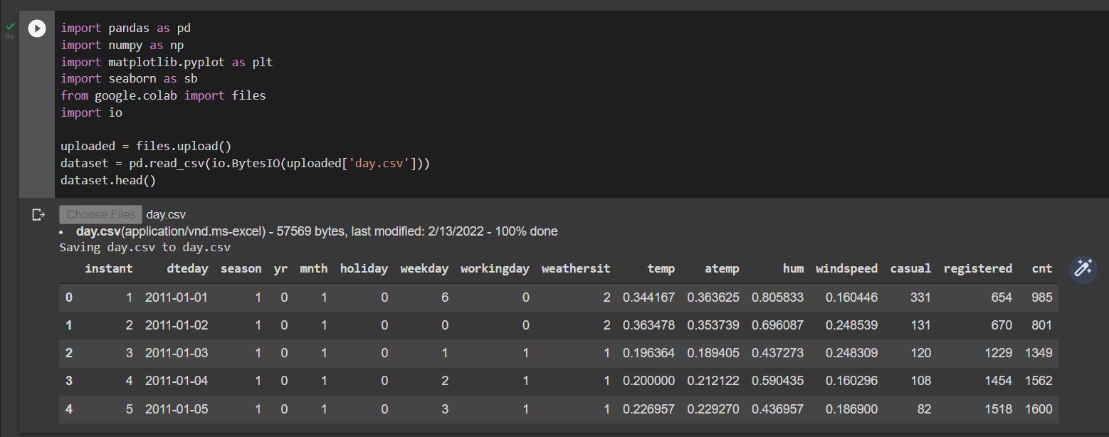

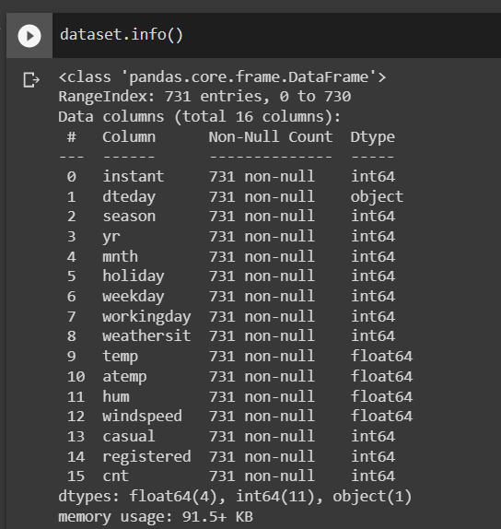

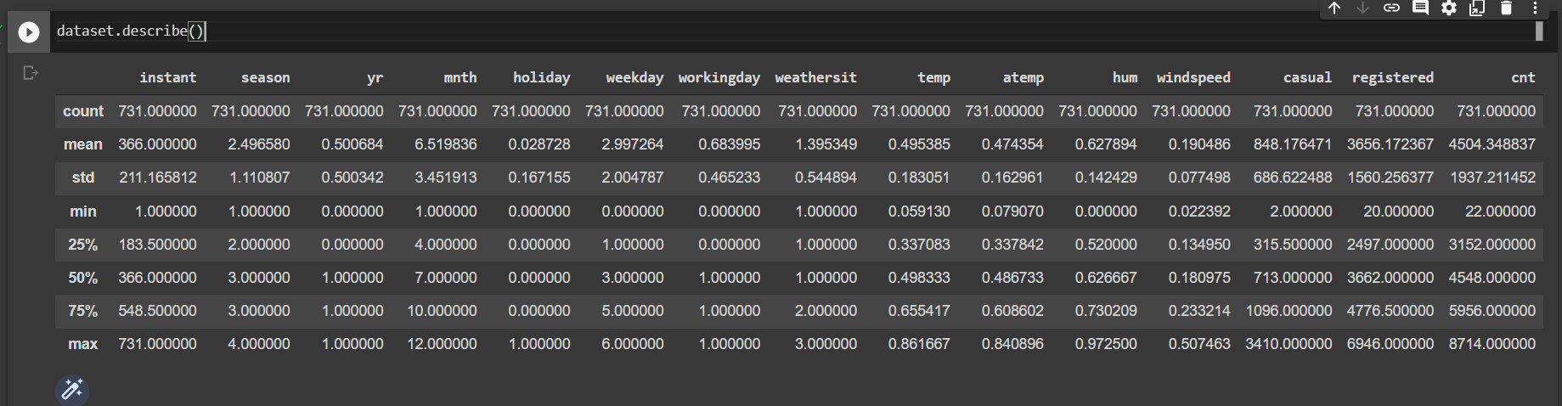

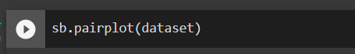

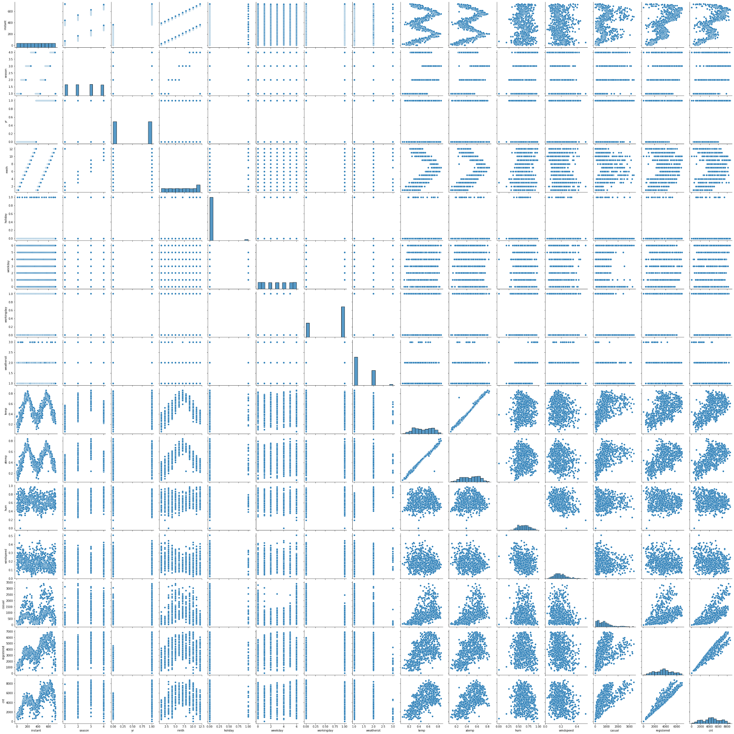

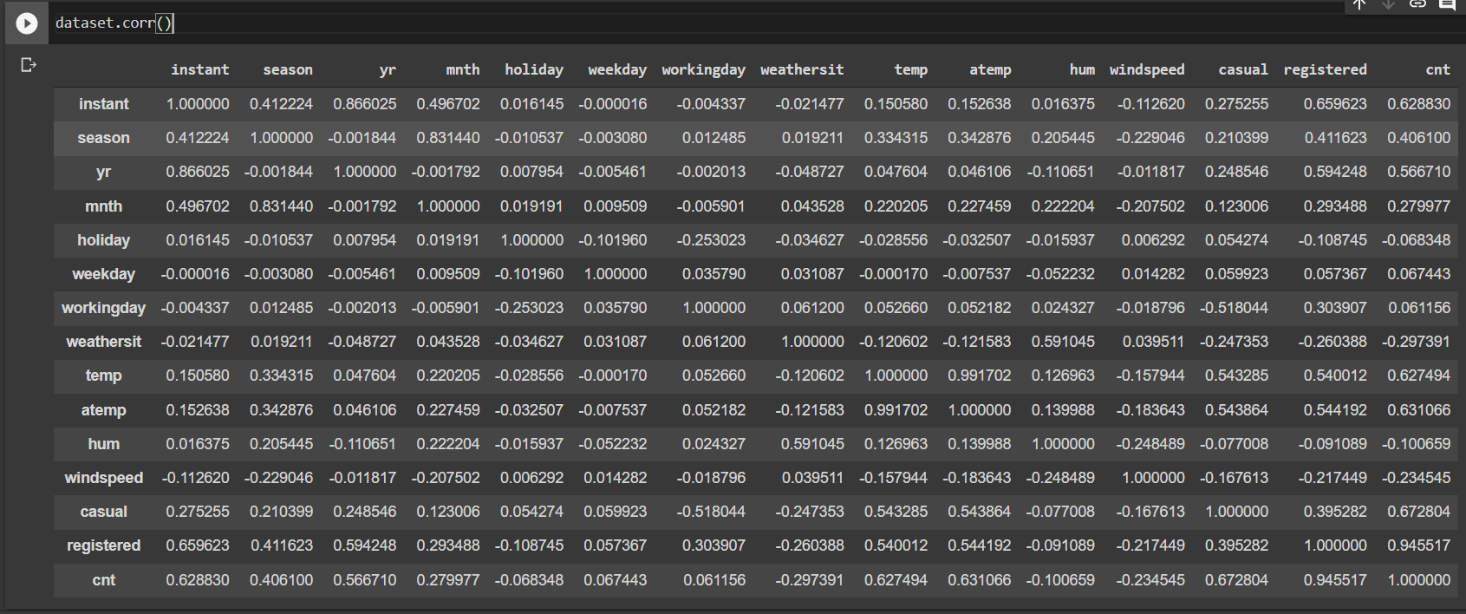

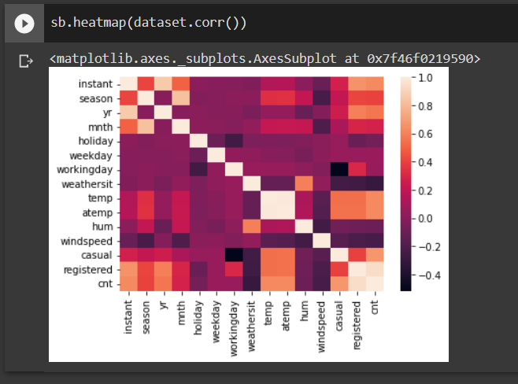

Training:

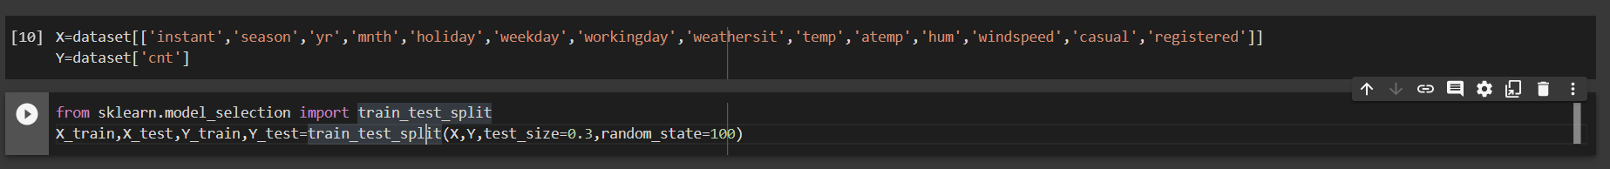

Linear regression:

